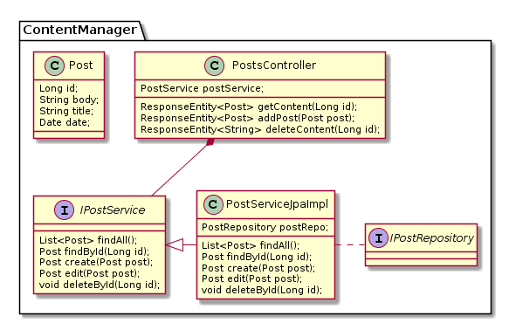

@startuml

package ContentManager{

class PostsController {

PostService postService;

ResponseEntity<Post> getContent(Long id);

ResponseEntity<Post> addPost(Post post);

ResponseEntity<String> deleteContent(Long id);

}

interface IPostService{

List<Post> findAll();

Post findById(Long id);

Post create(Post post);

Post edit(Post post);

void deleteById(Long id);

}

class PostServiceJpaImpl{

PostRepository postRepo;

List<Post> findAll();

Post findById(Long id);

Post create(Post post);

Post edit(Post post);

void deleteById(Long id);

}

IPostService<|-right- PostServiceJpaImpl

PostsController \*-- IPostService

PostServiceJpaImpl .right. IPostRepository

class Post {

Long id;

String body;

String title;

Date date;

}

interface IPostRepository {

}

}

@endu